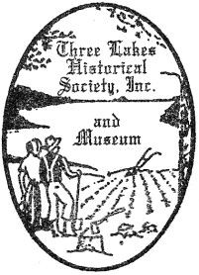
Donation Information Form & Deed of Gift
Circle one: museum’s copy donor’s copy

Name: _____________________________________________ Phone: _______________________
Address: ___________________________________________ Email: _______________________
I own the personal property described/pictured below and desire to give said personal property to the museum. I do hereby irrevocably and unconditionally give and transfer to the museum all right, title and interest, including all copyright, trademark and related interests, in and to the following described property. The Society may use its discretion to dispose of materials inappropriate for its collections, unless instructions to return unwanted materials to donor are stated below.

Item # | Description and Provenance
1
2
3
4
5
6
7
8
9
10
Return instructions: _______________________________________________________________________
This gift is given in memory of: _____________________________________________________________
Donor signature: __________________________ Acceptor signature: _____________________________
Date: ____________ Date: ____________
_ _ _ _ _ _ _ _ _ _ _ _ _ _ _ _ _ _ _ _ _ _ _ _ _ _ _ _ _ _ _ _ _ _ _ _ _ _ _ _ _ _ _ _ _ _ _ _ _ _ _ _ _ _ _ _ _ _ _ _ _ _ _ _ _ _ _ _ _ _ _ _ _ _ _ _ _ _ _ _ _ _ _ _ _ _ _ _ _ _ _
MUSEUM USE ONLY: Accession #: __________________
Date | Accessioned | Date | Returned | Date | Discarded | Date | Deaccessioned

